Statistical analysis of gut microbiome in cases of health and disease

Table 1 Data sets collected and processed through standardized pipeline

Dataset ID | Controls | N (controls) | Cases | N (cases) | Reference
Gevers 2014, IBD | non-IBD | 16 | CD | 146 | 26
Morgan 2012, IBD | H | 18 | UC, CD | 108 | 27
Papa 2012, IBD | non-IBD | 24 | UC, CD | 66 | 19
Willing 2010, IBD | H | 35 | UC, CD | 45 | 28

Non-IBD controls are patients with gastrointestinal symptoms but no intestinal inflammation. CD Crohn’s disease. UC ulcerative colitis.

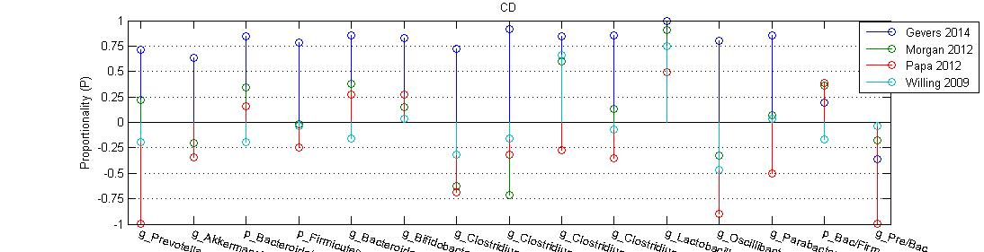

Proportionality (P). P=(d-h)/(d+h)

